The Man Who Walked Between the Towers

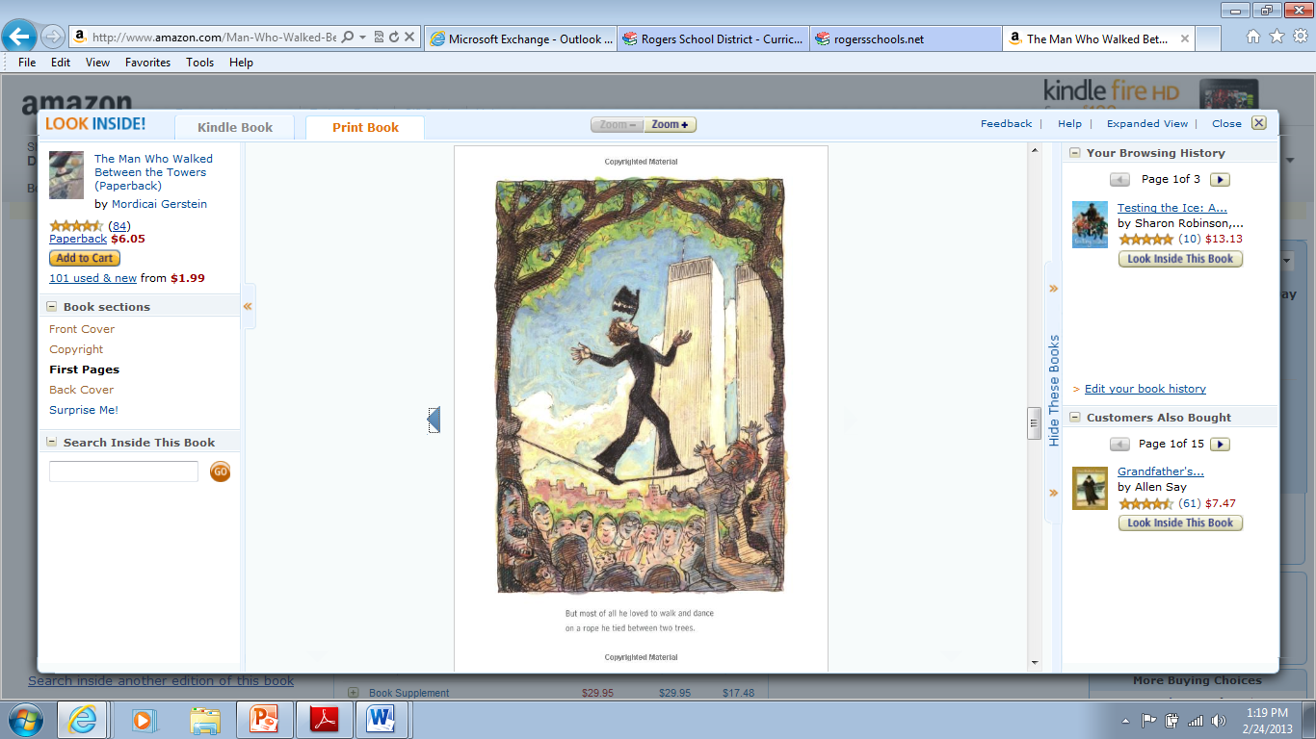

**1** The wire is tied between the ___________.

towers trees trips toes

**2** The people __________ as he walks.

cheer cry run dance

**3** Philippe has a hat ____________ on his nose.

balanced driving wearing flying

**4** A large group of people is a...

school flock pride crowd